Intro:
Mount Erebus Volcano, Ross Island, Antarctica hosts a convecting lava lake with regular explosive eruptions documented in dense broadband seismic data. The structural complexity of the volcano causes strong scattering of seismic waves that presents challenges in distinguishing between seismic sources using direct wave analysis methods. Convolutional Neural Networks have well-recognized potential to classify seismic events, but are limited in their ability to recognize long-term dependencies within signals. Despite recent steps forward in deep learning for seismic analysis, few studies have explored Transformer architecture for event detection or classification. Transformers have shown some potential in classifying acoustic time series data while incorporating longer term context, which is a critical component of seismic event detection, especially at Volcanoes, where individual seismic signals can be extremely variable due to scattering.
Data collection:
Data used in this study is open access seismic data from the 2007-2009 near-summit Tomo Erebus experiment, where a multichannel broadband array was installed on Mount Erebus, Ross Island, Antarctica. 4 known eruption signals serve as “templates” for the extraction of other events using the matched filtering method, where waveforms with high similarity are extracted from the large time series. In this study, we use data from December 10th through the 22nd 2008, which is the time period when the known eruptions were detected. By using the highest correlated picks from this small time window it is more likely that waveforms will be similar in spite of the evolving system of magmatic plumbing at Mount Erebus.
Pre-processing:
Raw signals are pre-processed using standard signal processing techniques such as a 1-10Hz bandpass filter (filters out the less-informative high and low frequencies), de-meaning and normalization by mean absolute deviation (reduces large amplitude discrepancies between stations), de-trending and dividing by instrument sensitivity (remove instrument response and convert data to units velocity). Then, 4 known eruption signals are cross-correlated with data from December 10th–27th, 2008 in order to build a catalog of 57,031 seismic traces. This technique, called matched filtering, is a means to develop a catalog of clustered eruptions at Erebus by extracting highly correlated waveforms and iteratively detecting new events. Highly correlated waveforms are from events which have highly similar sources (size, origin) and wave propagation paths (path from source to instrument). Each data class represents a different type of volcanic eruption, different in the characteristic shape of their waveforms. The differences between them are statistically significant, and more research is currently being done to fully characterize them in terms of the volcano’s condiut system (magma plumbing system), especially in the “tails” of the waveform, where the frequency contents are especially descriptive of the type of eruption (primarily distinguishing between gas slugs, or gas bubbles, of different sizes exiting the lava lake). Here we collect samples from the tails of events, ~10s after the initial event onset, to attempt to characterize this behavior.
Data is arranged in a .csv file where the first column is a label (0-4), and the second 4000 columns make up the seismic trace. Class 0 is columns which contain no notable seismic event and were extracted in the time period 70 seconds after a detected event when there is low likelihood of detecting another (author note- this decision was made earlier in first semester of graduate school and with the opportunity to re-extract this data I would have chosen instead to randomly select non-event time periods instead to avoid the gradual amplitude decay throughout these signals). There are noticeably higher amplitudes in these traces after normalization because of the less pronounced peak towards the beginning. Consistent amplitudes throughout the signal is characteristic of noise.
Classes are distributed evenly, with 10,000-12,000 examples of each. Waveforms are noticeably unique, with most characteristic behavior towards the beginning of the waveform. The differences between waveforms in the later half of the waveforms are noise, which varies based on individual channels and is likely much less significant in the classification of events. Cutting waveforms to shorter timestamps becomes necessary for the transformer due to the computational demands of the attention block, even on a larger machine.
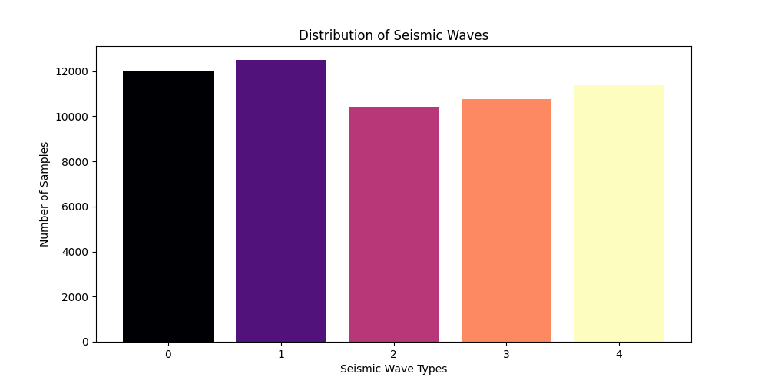

Transformer architecture.
This transformer is focused on classification of seismic time series data into multiple classes. It implements a single layer, multi headed attention mechanism designed for sequence classification. The multi headed attention component has separate projections for queries, keys, and values, plus an output projection, all of which are linear. The classification head uses token pooling to extract only the first token’s representation and sends it through a linear classifier.
Model inputs, originally 2000 samples long, are standardized using standard deviation to prevent underflow, and linearly mapped into 64 dimensions (embedding_dim). They additionally need positional encoding for the attention layer. The final input is a sum of the projected and positionally encoded raw input.
The simplicity of this model was chosen based on the limited amount of data available for training. First the data goes through a self attention layer. There is only one attention layer with 4 heads and 64 hidden dimensions. The self-attention layer uses the same embedding sequence as Q, K, V. Dropout is set to 0.3 for regularization. Next, the classification head pools and maps the input into 5 classes and outputs the probabilities of the sequence being a part of each class.
Transformer training parameters:
The training configuration has the following parameters.
- Optimizer: AdamW (lr=0.01, betas=(0.9, 0.98), eps=1E-9)
- Loss: Cross-entropy loss with class balancing weights
- Batch size: 32
- Dataset split: 60% train, 20% validation, 20% test
- Xavier initialization
The single attention layer was chosen due to the computational constraints of a larger model. Similarly, the amount of available data was a limitation for training a model to generalize well on the data with large numbers of features.
Transformer results:
The transformer model was unable to learn effectively from the data. While the training loss stabilized, the model was not consistently able to exceed the random guessing probability (20%) in the validation accuracy. Even after extensive hyperparameter tuning, this model failed to have meaningful performance, indicating that the model architecture may have been unsuitable for the problem, requiring further modification, or indicating that more data is necessary in order to properly generalize this seismic activity.
